# **Power BI Dashboard Report: ShopNest Retail Capstone Project**

## ****Overview****

This document explains the Power BI dashboard I created as part of my capstone project for ShopNest Store.

## ****Slicers Used in Dashboard****

To make the dashboard more interactive, I used the following slicers:

* **Year Slicer** - Helps filter the data by a specific year.
* **Product Category Slicer** - Allows focusing on sales, ratings, or delays based on individual product categories.
* **Customer State Slicer** - Helps examine state-wise sales or performance.
* **Delivery Status slicer – Helps filter the data by a specific delivery status.**

## ****Tasks and Visuals****

### ****Task 1: Identify and visually represent the top 10 product categories by total sales.****

* **Visualization:**   
    
  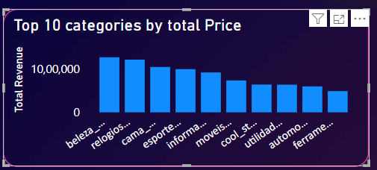  
    
  **Explanation:** I used a Clustered Column chart to show which 10 product categories had the highest total sales. This makes it easy to spot which product types are the most successful and contribute most to the business’s revenue.

### ****Task 2: Determine the number of delayed orders in each category. An order is considered delayed if the actual delivery date is later than the estimated delivery date.****

* **Visualization:**   
    
  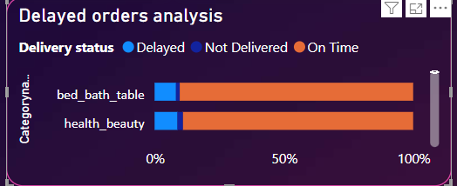  
    
  **Explanation:** This chart shows how many orders were delayed in each product category. I calculated delay by checking if the actual delivery date was later than the estimated one. This visual helps identify which categories often face delivery delays.

### ****Task 3: Create a dynamic visual that compares delayed vs on-time orders monthly. Include drillthrough for detailed views.****

* **Visualization:**   
    
  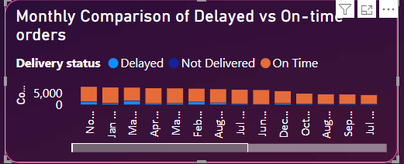  
    
  **Explanation:** The stacked column chart compares how many orders were on-time vs delayed for each month. I added a drillthrough feature so when a user clicks on a column, it opens a separate page showing detailed data for that month and delivery type.

### ****Task 4: Analyze the most frequently used payment methods using suitable visuals.****

* **Visualization:**   
    
  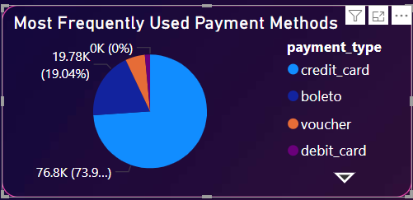
* **Explanation:** The pie chart shows which payment methods (like credit card, debit card, etc.) are used most often by customers. This helps understand customer preferences and plan future payment options accordingly.

### ****Task 5: Determine the top 10 highest-rated and bottom 10 lowest-rated products using bar/column charts.****

* **Visualization:**   
    
  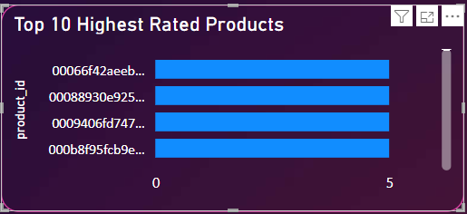
* **Explanation:** I created a bar chart for the 10 products with the highest review scores. This helps identify the best and worst performing products in terms of customer satisfaction.

### ****Task 6: Identify and visually represent states with high and low sales.****

* **Visualization:**   
    
  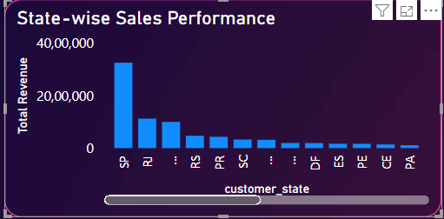  
    
  **Explanation:** This visual highlights how sales vary by state. It helps understand which regions perform well and which may need more attention in terms of marketing or service improvement.

### ****Task 7: Investigate and visualize seasonal patterns (quarterly) in sales data.****

* **Visualization:**   
    
  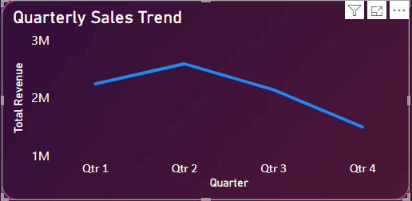  
    
  **Explanation:** I used a line chart to show sales by quarter. This helps spot seasonal trends—for example, which quarters have high or low sales—so the business can plan better for future seasons.

### ****Task 8: Determine total revenue and show how it changes yearly.****

* **Visualization:**   
    
  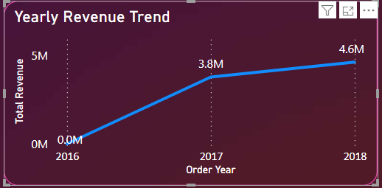  
    
  **Explanation:** This chart shows how the business’s revenue changes from year to year. It gives a quick view of growth trends or any drops in sales over time.

****